**fast Electronic Medical Records (fEMR)**

Product Design Specification

Version *1.0*

*10/22/2014*

**VERSION HISTORY**

|  |  |  |  |  |  |
| --- | --- | --- | --- | --- | --- |
| **Version #** | **Implemented By** | **Revision Date** | **Approved By** | **Approval Date** | **Reason** |
| 1.0 | Arslan Gondal  Khoa Le  Ken Dunlap | 10/22/14 |  |  | Initial Draft |
|  |  |  |  |  |  |
|  |  |  |  |  |  |

**TABLE OF CONTENTS**

1. Introduction4

1.1 Purpose4

**1.2 Scope4**

**1.3 Definitions and Abbreviations4**

2. General Overview and Design Guidelines/Approach4

2.1 Assumptions and Constraints4

2.1.1 Assumptions4

2.1.2 Business Constraints5

2.1.3 Technical Constraints5

3. Architecture Design5

3.1 Hardware Architecture5

3.2 Software Architecture6

3.2.1 Existing fEMR System6

3.2.2 Graph Data Requests (JSON Objects)7

3.4 Security Architecture8

4. System Design9

4.1 Use Cases9

4.1.1 Actors9

4.1.2 List of Researcher Use Cases9

4.1.3 Use Case Diagram9

4.1.4 Use Cases10

4.2 Sequence Diagrams14

4.3 Data Flow Diagram14

4.4 Database Design14

4.5 Class Diagram16

4.6 Application Program Interface16

4.7 User Interface Design16

2. Product Design Specification Approval19

1. **Introduction**

**1.1 Purpose of the Product Design Specification Document**

The Product Design Specification document documents and tracks the necessary information required to effectively define architecture and system design in order to give the development team guidance on architecture of the system to be developed. The Product Design Specification document is created during the Planning Phase of the project. Its intended audience is the project manager, project team, and development team. Some portions of this document such as the user interface (UI) may on occasion be shared with the client/user, and other stakeholder whose input/approval into the UI is needed.

**1.2 Scope**

This document is for a feature addition to an already existing medical record system. The new research feature will utilize the underlying data from the existing system to create a base level data visualization system that will be expanded upon in future updates. The focus will be placed on gathering, packaging and displaying patient data for display in several types of graphs.

**1.3 Definitions and Abbreviations**

* **fEMR -** fast Electronic Medical Record
* **Graph** - refers to any of the available visualization models and in some cases could be interchangeable with chart. We will stick to graph for consistency.

1. **General Overview and Design Guidelines/Approach**

This section describes the principles and strategies to be used as guidelines when designing and implementing the system.

**2.1 Assumptions and Constraints**

**2.1.1 Assumptions**

* The research features will be an extension to the current fEMR system and will expand upon existing functionality.
* Doctors, nurses, and pharmacists who may have limited a technological skillset will use the research portion of the fEMR system.
* The specifications outlined here are meant to be the baseline functionality that can be expanded upon in future updates.

**2.1.2 Business Constraints**

* Weak network signal due to only having limited access to a power source. (fEMR team will have access to a generator with only one outlet.)
* Lack of medical knowledge. It hard to know exactly what types of graphs and charts are most useful to the medical team at fEMR.
* Project must be completed by the first week of December. A team will be deployed by the second week of December.

**2.1.3 Technical Constraints**

We are adding to an existing project and are required to use the following:

* Deployable in a Linux Environment
* Functional on tablets and desktop computers with a resolution of 768px wide or higher

1. **Architecture Design**

This section outlines the system and hardware architecture design of the system that is being built.

**3.1 Hardware Architecture**

The fEMR system is setup on a private network with devices communicating wirelessly with a Linux webserver.

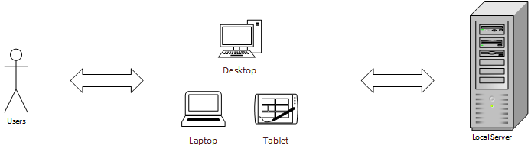

**3.2 Software Architecture**

**3.2.1 Existing fEMR System**

The existing fEMR system is build with an N-Tier architecture.

The UI layer is built with an MVC design pattern. The Controllers are responsible for communication between the UI and other layers of the system. The Models of the UI only view data and do not represent the data in the database. The service layer is where most of the business logic in the system lives. The data layer handles all database operations.

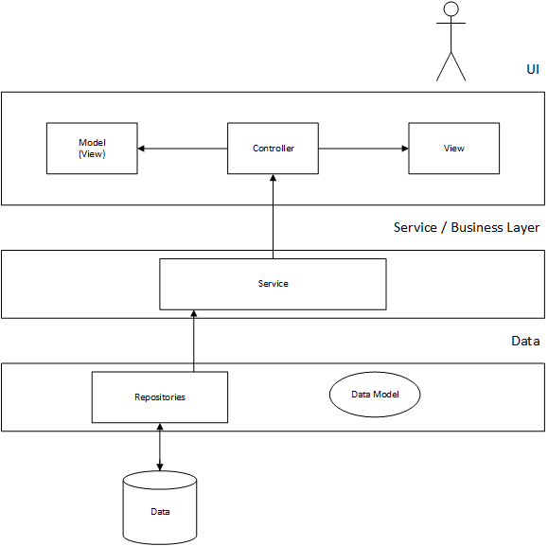

**3.2.2 Graph Data Requests (JSON Objects)**

Graph data is sent to the browser via a JSON object. Every request will have common pieces of information, but the structure of the data to be charted will vary based on the type of graph.

On a general scale, once a request for graph data has been made, the Controller will dispatch to the Service layer to gather the required info from the Data layer. Then the Controller will package the database info in the correct JSON object for the JavaScript to build a graph.

The JSON objects will be formatted as:

Object {

average: *number formatted for display,*

median: *number formatted for display,*

rangeHigh: *number formatted for display,*

rangeLow: *number formatted for display,*

graphData: *(defined below)*

}

**Bar Graph:** (Array of objects)

graphData: [

{

key: “X-axis label”

value: *integer (number of patients)*

},

]

**Pie Graph:** (Array of objects)

graphData: [

{

key: “X-axis label”

value: *integer (number of patients)*

},

]

**Line Graph:** (Array of numbers)

graphData: [num, num, num, num, … ]

**Scatterplot Graph:** (Array of numbers)

graphData: [num, num, num, num, … ]

**Stacked Bar Graph:** (2-Dimensional Array of objects)

graphData: [

[

{

key: “X-axis label”

value: *integer (number of patients)*

},

],

[

{

key: “X-axis label”

value: *integer (number of patients)*

},

]

]

**Grouped Bar Graph:** (2-Dimensional Array of objects)

graphData: [

[

{

key: “X-axis label”

value: *integer (number of patients)*

},

],

[

{

key: “X-axis label”

value: *integer (number of patients)*

},

]

]

**Table View:** (Array of objects)

graphData: [

{

key: “X-axis label”

value: *integer (number of patients)*

},

]

**3.4 Security Architecture**

Access to the fEMR system is already secured with a login system that controls user access through roles. Users to the Research portion must be assigned the Researcher role by an Administrator.

1. **System Design**

**4.1 Use-Cases**

**4.1.1 Actors**

There are several user types in the base fEMR system, but we will only be concerned with one type.

**Researchers** - any user who has been assigned the researcher role/privilege by an Administrator. Researchers may be Doctors, Nurses, Pharmacists or other Administrators in the fEMR group.

**4.1.2 List of Researcher Use Cases**

UseCaseID_1 Request graph with 1 dataset

UseCaseID_2 Request graph with 2 datasets

UseCaseID_3 Request graph with custom date filter

UseCaseID_4 Save current graph as an image

**4.1.3 Use Case Diagram**

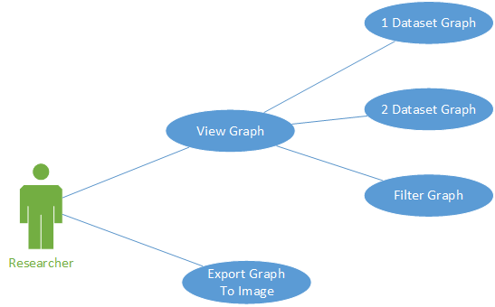

**4.1.4 Use Cases**

|  |  |  |  |  |
| --- | --- | --- | --- | --- |
| **Use Case ID:** | UseCaseID_1 | | | |
| **Use Case Name:** | Request graph with 1 dataset | | | |
| **Created By:** | Arslan Gondal | | **Last Updated By:** | Khoa Le |
| **Date Created:** | 10/18/2014 | | **Last Revision Date:** | 10/21/2014 |
| **Actors:** | | The actor will be a medical professional, who after a session of patient visits, will sit down at a computer or tablet and review the data collected by the fEMR system. The actor will be referred to as a researcher. | | |
| **Description:** | | This use case describes the request of a graph with 1 dataset type. In this use case the actor’s goal is to view a graph given the elements the actor has chosen. | | |
| **Trigger:** | | The researcher logs into the fEMR system wishing to view graphs, and opens the research tab. | | |
| **Preconditions:** | | 1. The researcher must have a valid session within fEMR. 2. The researcher must be using chrome on a desktop/laptop or a tablet device in landscape. 3. The user must be on the same network as the fEMR network. | | |
| **Postconditions:** | | A graph has been rendered within the web browser of the actor. | | |
| **Normal Flow:** | | 1. Researcher selects 1 type of data from the DataSet 1 menu, a graph type, a filter for the dates, and graph options. 2. JavaScript sends Ajax request to the server 3. Server packages requested data and returns JSON object 4. D3 JavaScript library renders graph. | | |
| **Alternative Flows:**  **[Alternative Flow 1 – No Data Found]** | | 4a. In step 4 of the normal flow, if no matching data is found   1. JavaScript will change DOM to notify the user that no data was found to be graphed. 2. Researcher will not be further prompted, but may return to step 1. | | |
| **Exceptions:** | | 1a. In step 1 of the normal flow, if a user selects invalid filters (e.g. end date before start date)   1. JavaScript informs of researcher invalid selection 2. User reselects filters 3. Use Case continues at step 2 | | |
| **Frequency of Use:** | | This use case may be used hundreds of times in a day, but usually on-demand. | | |
| **Special Requirements:** | |  | | |
| **Assumptions:** | | 1. The researcher understands English. 2. The researcher understands the naming of each data set and what data they represent. 3. The researcher understands the various graph types. | | |

|  |  |  |  |  |
| --- | --- | --- | --- | --- |
| **Use Case ID:** | UseCaseID_2 | | | |
| **Use Case Name:** | Request graph with 2 datasets | | | |
| **Created By:** | Arslan Gondal | | **Last Updated By:** | Ken Dunlap |
| **Date Created:** | 10/18/2014 | | **Last Revision Date:** | 10/20/2014 |
| **Actors:** | | The actor will be a medical professional, who after a session of patient visits, will sit down at a computer or tablet and review the data collected by the fEMR system. The actor will be referred to as a researcher. | | |
| **Description:** | | This use case is meant to reflect a scenario in which a researcher wishes to see the relationship between two different patient attributes observed during patient visits over a specified time period. | | |
| **Trigger:** | | The researcher logs into the fEMR system wishing to view graphs, and opens the research tab. | | |
| **Preconditions:** | | 1. The researcher must have a valid session within fEMR. 2. The researcher must be using chrome on a desktop/laptop or a tablet device in landscape. 3. The user must be on the same network as the fEMR network. | | |
| **Postconditions:** | | A graph has been rendered within the web browser of the actor. | | |
| **Normal Flow:** | | 1. Researcher selects data set 1, data set 2, graph type, filter and other graph options and clicks Apply 2. JavaScript sends Ajax request to the server 3. Server packages requested data and returns JSON object 4. D3 JavaScript library renders graph. | | |
| **Alternative Flows:**  **[Alternative Flow 1 – No Data Found]** | | 4a. In step 4 of the normal flow, if no matching data is found   1. JavaScript will change DOM to notify the user that no data was found to be graphed. 2. Researcher will not be further prompted, but may return to step 1. | | |
| **Exceptions:** | | 1a. In step 1 of the normal flow, if a user selects invalid filters (e.g. end date before start date)   1. JavaScript informs of researcher invalid selection 2. User reselects filters 3. Use Case continues at step 2 | | |
| **Includes:** | |  | | |
| **Frequency of Use:** | | This use case may be used hundreds of times in a day, but usually on-demand. | | |
| **Special Requirements:** | |  | | |
| **Assumptions:** | | 1. The researcher understands English. 2. The researcher understands the naming of each data set and what data they represent. 3. The researcher understands the various graph types. | | |
| **Notes and Issues:** | |  | | |

|  |  |  |  |  |
| --- | --- | --- | --- | --- |
| **Use Case ID:** | UseCaseID_3 | | | |
| **Use Case Name:** | Request graph with custom date filter | | | |
| **Created By:** | Arslan Gondal | | **Last Updated By:** | Ken Dunlap |
| **Date Created:** | 10/18/2014 | | **Last Revision Date:** | 10/21/2014 |
| **Actors:** | | The actor will be a medical professional, who after a session of patient visits, will sit down at a computer or tablet and review the data collected by the fEMR system. The actor will be referred to as a researcher. | | |
| **Description:** | | This use case is meant to reflect a scenario in which a researcher wishes to see the relationship between two different patient attributes observed during patient visits over a specified time period. | | |
| **Trigger:** | | The researcher logs into the fEMR system wishing to view graphs, and opens the research tab. | | |
| **Preconditions:** | | 1. The researcher must have a valid session within fEMR. 2. The researcher must be using chrome on a desktop/laptop or a tablet device in landscape. 3. The user must be on the same network as the fEMR network. | | |
| **Postconditions:** | | A graph has been rendered within the web browser of the actor. | | |
| **Normal Flow:** | | 1. Researcher selects data set 1, data set 2, graph type, a custom date range and clicks Apply 2. JavaScript sends Ajax request to the server 3. Server packages requested data and returns JSON object 4. D3 JavaScript library renders graph. | | |
| **Alternative Flows:**  **[Alternative Flow 1 – No Data Found]** | | 4a. In step 4 of the normal flow, if no matching data is found   1. JavaScript will change DOM to notify the user that no data was found to be graphed. 2. Researcher will not be further prompted, but may return to step 1. | | |
| **Exceptions:** | | 1a. In step 1 of the normal flow, if a user selects invalid filters (e.g. end date before start date)   1. JavaScript informs of researcher invalid selection 2. User reselects filters 3. Use Case continues at step 2 | | |
| **Includes:** | |  | | |
| **Frequency of Use:** | | This use case may be used hundreds of times in a day, but usually on-demand. | | |
| **Special Requirements:** | |  | | |
| **Assumptions:** | | 1. The researcher understands English. 2. The researcher understands the naming of each data set and what data they represent. 3. The researcher understands the various graph types. | | |
| **Notes and Issues:** | |  | | |

|  |  |  |  |  |
| --- | --- | --- | --- | --- |
| **Use Case ID:** | UseCaseID_4 | | | |
| **Use Case Name:** | Save Current Graph as Image | | | |
| **Created By:** | Arslan Gondal | | **Last Updated By:** | Khoa Le |
| **Date Created:** | 10/18/2014 | | **Last Revision Date:** | 10/21/2014 |
| **Actors:** | | The actor will be a medical professional, who after a session of patient visits, will sit down at a computer or tablet and review the data collected by the fEMR system. The actor will be referred to as a researcher. | | |
| **Description:** | | This use case describes the request to save a graph as an image. | | |
| **Trigger:** | | The researcher logs into the fEMR system wishing to view graphs, and opens the research tab. | | |
| **Preconditions:** | | 1. The researcher must have a valid session within fEMR. 2. The researcher must be using chrome on a desktop/laptop or a tablet device in landscape. 3. The user must be on the same network as the fEMR network. 4. The user must have a graph D3 rendered graph displayed. | | |
| **Postconditions:** | | A graph was saved to the actor’s local hard drive. | | |
| **Normal Flow:** | | 1. User clicks Save image button on research page. 2. SVG image is converted to PNG using HTML5 CANVAS object 3. Object converted to IMG tag 4. User picks name for image and where to save image to | | |
| **Alternative Flows:**  **[Alternative Flow 1 – No Data Found]** | | 1a. In step 1 of the normal flow, if no matching data is found   1. JavaScript will change DOM to notify the user that graph was found to be saved. 2. Researcher will not be further prompted, but may return to step 1. | | |
| **Exceptions:** | |  | | |
| **Frequency of Use:** | | This use case may be used hundreds of times in a day, but usually on-demand. | | |
| **Special Requirements:** | |  | | |
| **Assumptions:** | | 1. The researcher understands English. 2. The researcher understands the naming of each data set and what data they represent. 3. The researcher understands the various graph types. | | |

**4.2 Sequence Diagrams**

*See 4.2-Sequence-Diagrams.pdf*

**4.3 Data Flow Diagram**

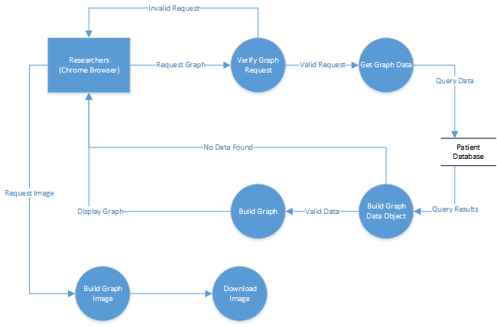

**4.4 Database Design**

The research portion for fEMR will leverage the existing database structure of the system. We will not be modifying any of the data, only reading needed info for graph and chart visualization.

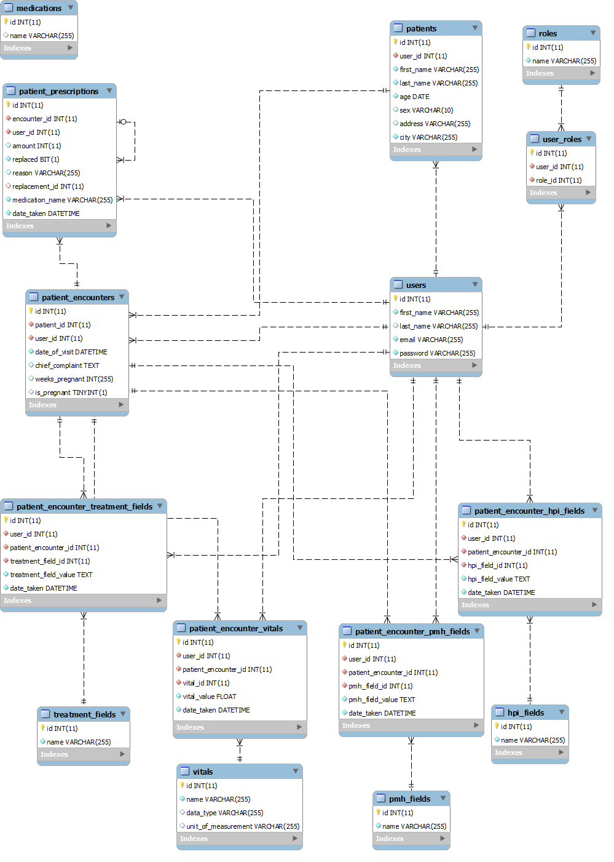

**4.5 Class Diagram**

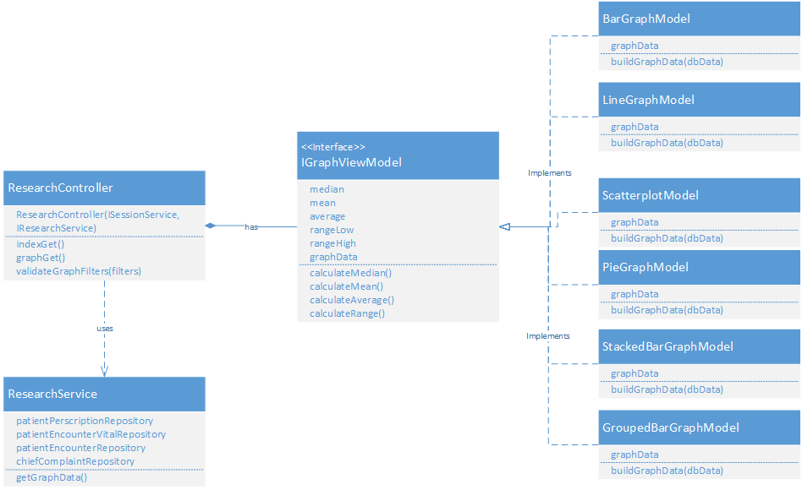

**4.6 Application Program Interface**

The D3.js library will be used to create and display graphs on the page. The D3 library is used to manipulate documents based on data and is built to work on modern web browsers

The queried patient data will be fed into D3.js in order to generate the potential graphs on page.

The official API reference can be found at:

https://github.com/mbostock/d3/wiki/API-Reference

**4.7 User Interface Design**

The User Interface will resize itself to fit within the browser window at 3 different pixel width breakpoints. These are based off of key breakpoints in the Twitter Bootstrap.

1. 768px and up
2. 992px and up
3. 1200px and up

At each breakpoint, the graph container div will resize to fill its parent div and Javascript will trigger re-drawing the graph.

**Basic UI Layout**

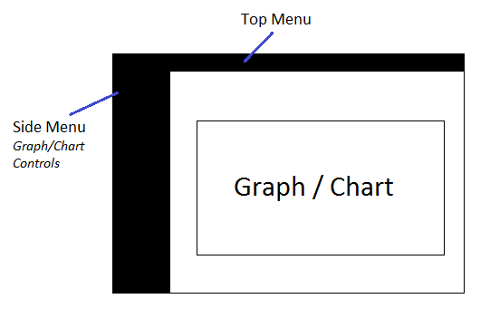

**Side Menu Graph/Chart Controls Detail**

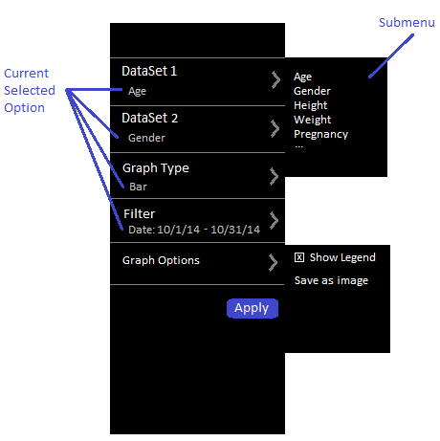

Users will be able to control the currently displayed graph through a toolbar that will stay docked on the left edge of the screen. The selectable options for each section will be editable through a submenu that will slide out from the right side of the toolbar. The submenus will overlay anything that might be in the right pane of the screen. Clicking (tapping) or hovering on each section will trigger display of the submenu.

The current selected options will be the subheading for each section. In the side menu controls mockup, Age is currently selected for Dataset 1. The Dataset 2 submenu will enable/disable based on the value chosen in Dataset 1. The available Graph Types will change based on the Dataset 1 value chosen.

When the User clicks the Apply button, the graph with the selected options will be displayed in the Graph/Chart area.

1. **Product Design Specification Approval**

The undersigned acknowledge they have reviewed the fEMR Product Design Specification document and agree with the approach it presents. Any changes to this Requirements definition will be coordinated with and approved by the undersigned or their designated representatives.

|  |  |  |  |
| --- | --- | --- | --- |
| Signature: |  | Date: |  |
| Print Name: |  |  |  |
| Title: |  |  |  |
| Role: |  |  |  |

|  |  |  |  |
| --- | --- | --- | --- |
| Signature: |  | Date: |  |
| Print Name: |  |  |  |
| Title: |  |  |  |
| Role: |  |  |  |

|  |  |  |  |
| --- | --- | --- | --- |
| Signature: |  | Date: |  |
| Print Name: |  |  |  |
| Title: |  |  |  |
| Role: |  |  |  |